MaxiCharger AC Maintenance Manual

Revision Date: 2022-11-25

Version Number: V1.0

version number

version number]

**Content**

1 Safety 1

1.1Safety Information 1

1.2 Safety Messages 1

1.3 Safety Instructions 1

2 Electrical measurement and part replacement 3

2.1 The tools to be prepared. 3

2.2 Electrical diagram 4

2.3 Electrical measurement 4

2.4 Replace the charging cable. (Only when the cable needs to be replaced. It’s not a routine maintenance item) 6

3 Check the light indication. 10

4 Functional test 12

**4.1** Start Charging 12

4.1.1 Cable Models 12

4.1.2 Socket/Shutter Models 12

**4.2** Stop Charging 13

4.2.1 Cable Models 13

4.2.2 Socket/Shutter Models 13

5 Troubleshooting and Service 15

**5.1** Troubleshooting Table 15

1. Safety
   1. Safety Information

For your own safety and the safety of others, and to prevent damage to the device and vehicles upon which it is used, it is important that the safety instructions presented throughout this manual be read and understood by all persons operating or coming into contact with the device.

* 1. Safety Messages

Safety messages are provided to help prevent personal injury and equipment damage. All safety messages are introduced by a single word indicating the hazard level.

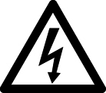**DANGER**

Indicates an imminently hazardous situation which, if not avoided, will result in death or serious injury to the operator or to bystanders.

**WARNING**

Indicates a potentially hazardous situation which, if not avoided, could result in death or serious injury to the operator or to bystanders.

* 1. Safety Instructions

****The safety messages herein cover situations Autel is aware of. Autel cannot know, evaluate or advise you as to all of the possible hazards. You must be certain that any condition or service procedure encountered does not jeopardize your personal safety.

**SAFETY WARNINGS**

* Read all the instructions before you use this device.
* Do not install or use the device near flammable, explosive, harsh, or combustible materials, chemicals, or vapors.
* Turn off power at the circuit breaker before installing or cleaning the device.
* This device should be supervised when used around children.
* This device must be grounded through a permanent wiring system or an equipment-grounding conductor.
* Use the device only within the specified operating parameters.
* Do not use the device if it is defective, appears cracked, frayed, broken or otherwise damaged, or fails to operate.
* Do not use the device if the flexible power cord or EV cable is frayed, broken, or otherwise damaged, or if it fails to operate.
* Do not attempt to disassemble, repair, tamper with or modify the device.
* Handle the device with care during transportation. Do not subject it to strong force or impact, pull, twist, tangle, drag or step on the device, to prevent damage to it and any of its components.
* Do not insert fingers or foreign objects into any part of the device.
* If any specifications or regulations mentioned in this manual contradict with your local rules, refer to your local rules.



**CAUTION**

* Do not use private power generators as a power source for charging.
* Incorrect installation and testing of the device could potentially damage the vehicle's battery, components, and/or the device itself.
* Do not operate the device in temperatures outside its operating range

1. Electrical measurement and part replacement
   1. The tools to be prepared.

|  |  |  |  |
| --- | --- | --- | --- |
| Multi-meter |  | Screwdriver  (type T25) |  |
| Screwdriver  (type T10) |  | Shifting Wrench |  |
| Screwdriver (PH2) |  | Safety Shoes |  |
| Safety Gloves |  |  |  |

* 1. 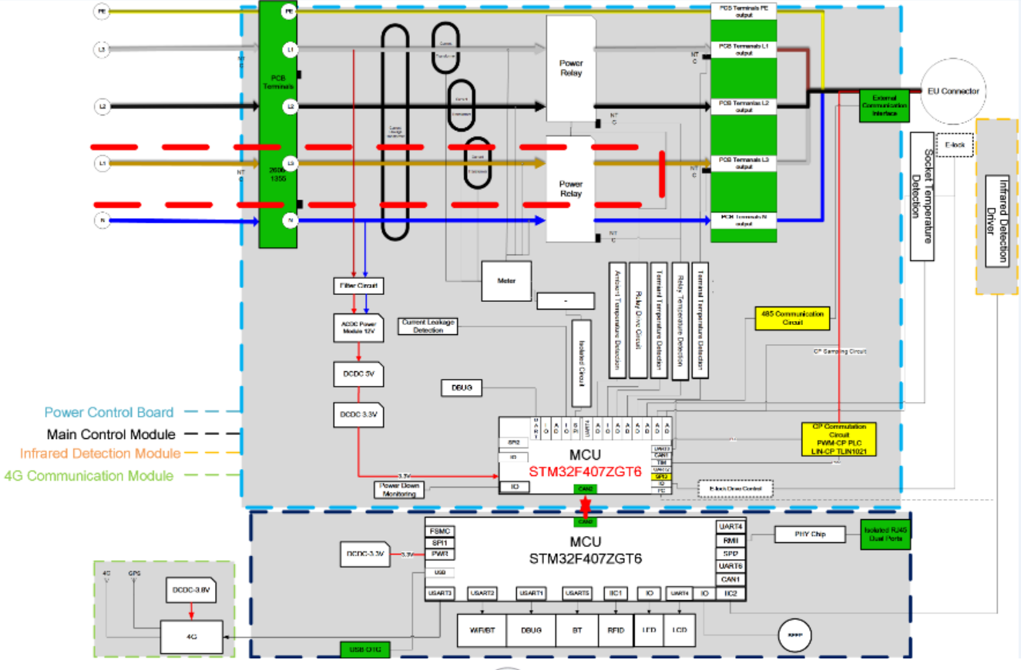Electrical diagram
  2. Electrical measurement

Measure the voltage with the multi-meter and compare to the normal value.

|  |  |  |
| --- | --- | --- |
| **Item of Measurement** | **Value** | **Normal Value** |
| L1-PE |  | 230V |
| L2-PE |  | 230V |
| L3-PE |  | 230V |
| N-PE |  | <70V |
| CP-PE |  | 12V |

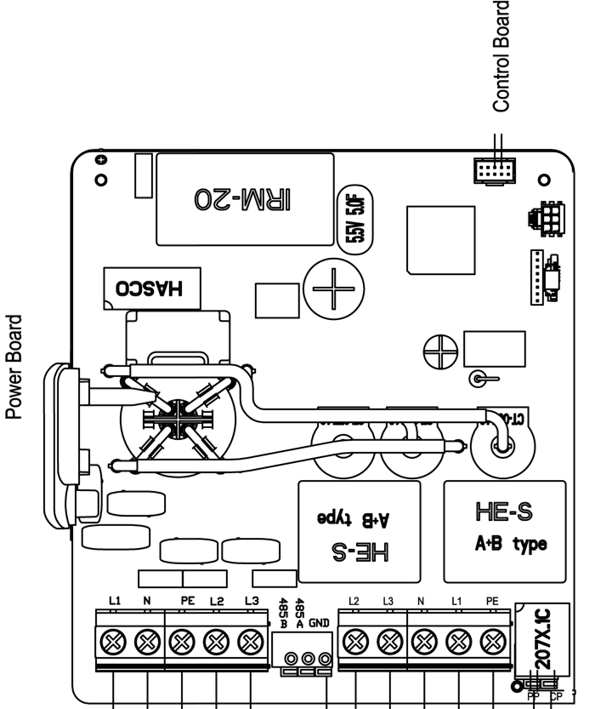

Also, there are no L2-PE and L3-PE to measure for the single phase charger.

* 1. Replace the charging cable. (Only when the cable needs to be replaced. It’s not a routine maintenance item)

1. Use T10 screwdriver to take out the two screws at the bottom of the charger and remove the faceplate.

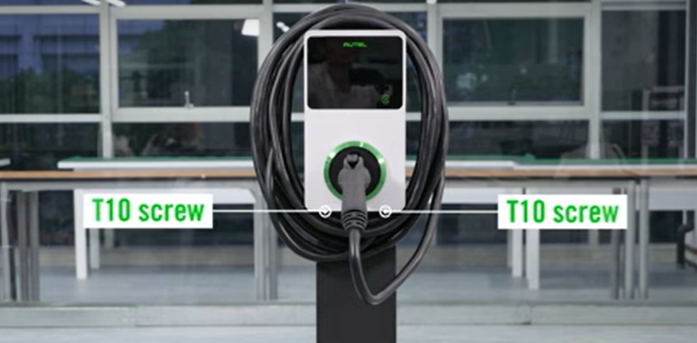

1. Take out the screws along the edge of the charger using the T10 screwdriver and take off the front cover.

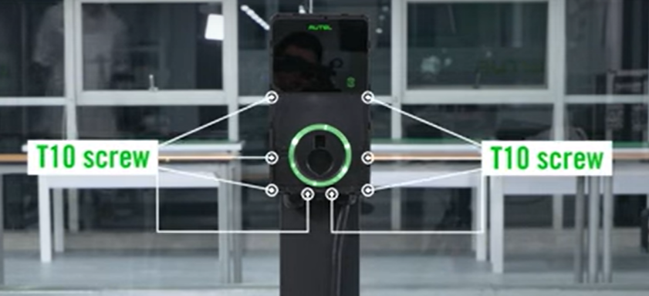

1. Loosen the cable connection.

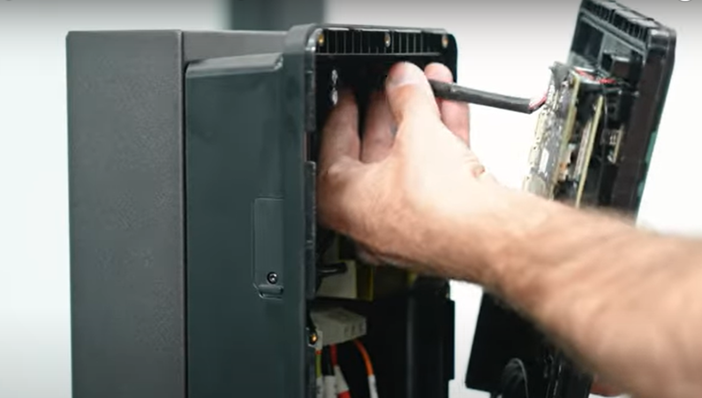

1. Loosen the terminal screws holding the wires with screwdriver.

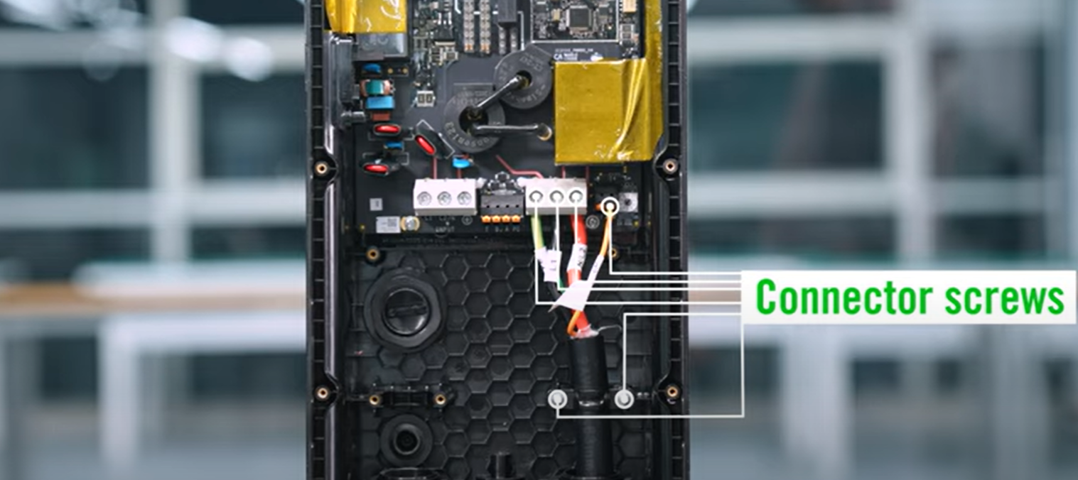

1. Loosen the cable sealing ring and take out the wires.

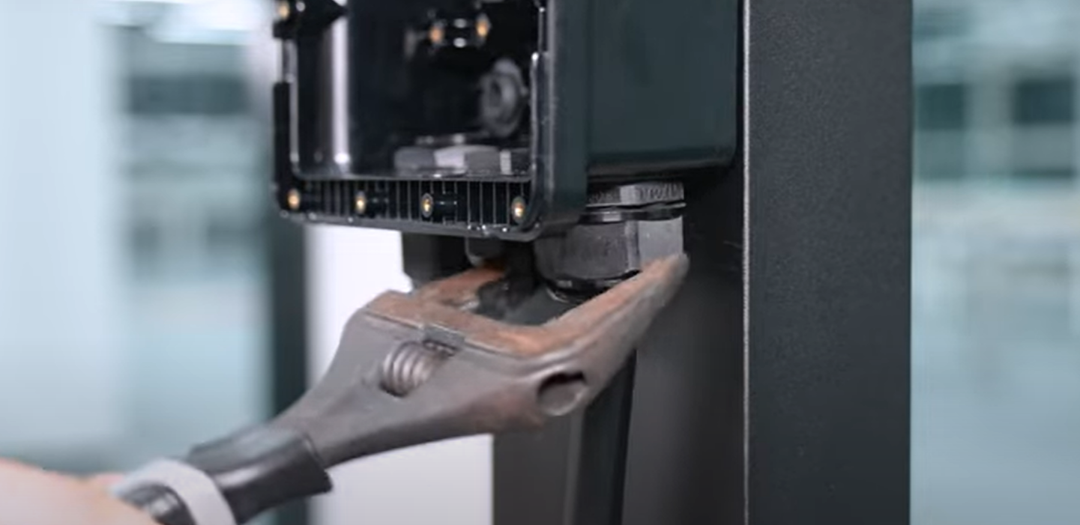

1. Take the new cable and insert it into the cable gland, insert the corresponding wires into the correct terminals. Tighten the screws using the screwdriver.

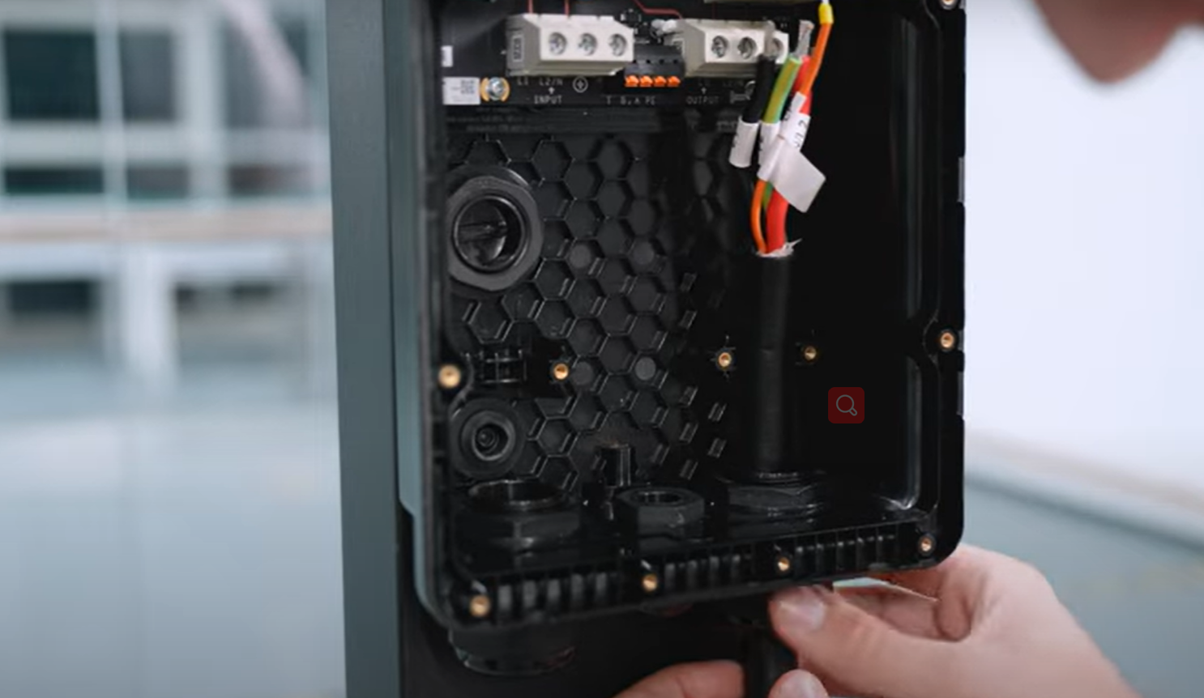

1. Recover the front cover and faceplate as before.

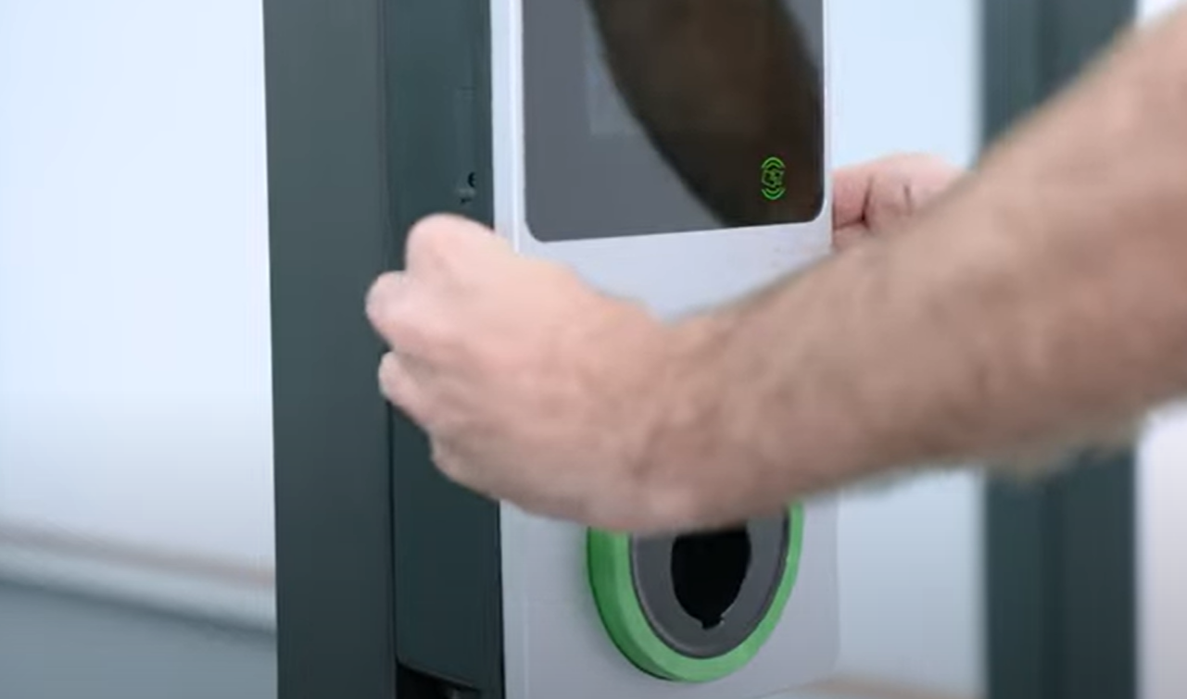

1. 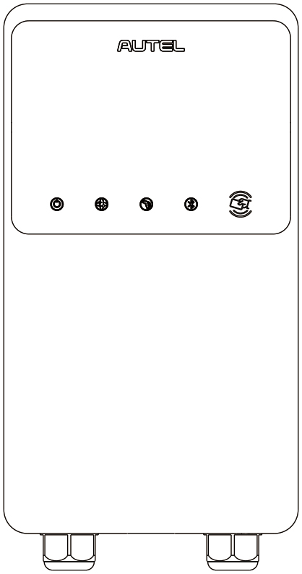Check the light indication.

LED Indicators (from left to right):

* Power LED
* Internet Connection LED
* Charging LED
* Bluetooth Connection LED

|  |  |
| --- | --- |
| **LED** | **Description** |
| **Power LED** | * **Solid Green:** The charger is on. * **Off:** The charger is off. * **Flashing Yellow:** Datais being transmittedand/orfirmware is upgrading. * **Solid Yellow:** Firmware upgrade has failed. * **Solid Blue:** Data transmission has failed; will turn solid green in five seconds (see above). |
| **Internet Connection LED** | * **Solid Green:** The charger is connected to the Internet. * **Off:** The charger is not connected to the Internet. * **Flashing Green:** The charger has joined the DLB (Dynamic Load Balancing) network. |
| **Charging LED** | * **Solid Blue:** An EV is connected. * **Flashing Blue:** A schedule is active. * **Flashing Cyan:** The charger is reserved. * **Flashing Green:** An EV is charging. * **Solid Orange:** A recoverable error has occurred or it is temporarily disabled by the server. * **Solid Green:** A charge session has ended. * **Off:** No EV connected. * **Solid Red:** An irrecoverable error has occurred. (Please contact support.) |
| **Bluetooth**  **Connection LED** | * **Flashing Green:** The charger is connected to a mobile device via Bluetooth. * **Flashing Blue:** The charger is connected to VCI (Vehicle Communication Interface) via Bluetooth. * **Flashing Cyan:** The charger is connected to a mobile device and a VCI device simultaneously via Bluetooth. * **Off:** The charger is not connected via Bluetooth. |

1. **Functional test**

**Warning**

Be careful when you work with electricity.

* 1. ** Start Charging**

**Caution**

During the charge session, do not disconnect the charging handle. There is a risk of damage to the cradle of the charger or the connector of your EV.

* + 1. **Cable Models**

1. Remove the charging handle from the cradle of the charger.
2. Insert the charging handle into the charge port on your EV.
3. Choose from the following four ways to start a charge session:

* Tap your RFID card on the RFID reader.
* Use the Autel Charge app by tapping **Start** on the Charge screen.
* If you have set a charging schedule in the Autel Charge app, the charger will initiate a charge session automatically as scheduled.
* If the Plug-and-charge function is enabled in the Autel Charge app, the charger will automatically start charging once the charging handle is properly connected.
  + 1. **Socket/Shutter Models**

1. Insert your charging handle into the charge port on your EV and the charger socket outlet.
2. Choose from the following four ways to start a charge session:

* Tap your RFID card on the RFID reader.
* Use the Autel Charge app by tapping **Start** on the Charge screen.
* If you have set a charging schedule in the Autel Charge app, the charger will initiate a charge session automatically as scheduled. (Scheduled charging case.)
* If the Plug-and-charge function is enabled in the Autel Charge app, the charger will automatically start charging once the charging handle is properly connected. (Plug-and-charge case.)

**NOTE**

Ensure your EV is charging. The charging LED on the charger should be flashing green. If you suspect the vehicle is not charging properly, try reconnecting the charge cable or contact the local dealer for support.

* 1. **Stop Charging**

**NOTE**

If you disconnect the EV charge cable during the charge session, the charger automatically disconnects the power supply. This stops all charging operations.

* + 1. **Cable Models**

1. To stop charging, you can choose either of the following two ways:

* Wait for the charge session to end and no further actions are required in the case of scheduled charging or plug-and-charge.
* The charging LED will light solid green.
* The Autel Charge app displays that your vehicle is fully charged.
* If the charger has a display, it will show that your vehicle is fully charged.

**NOTE**

When your vehicle is fully charged, the charger will automatically disconnect the power supply.

* End the charge session by tapping your RFID card on the RFID reader again or via the Autel Charge app by tapping **Stop** on the Charge screen.

1. Remove the charging handle from the vehicle charge port and return it to the cradle of the charger.
   * 1. **Socket/Shutter Models**
2. To stop charging, you can choose either of the following two ways:

* Wait for the charge session to end and no further actions are required in the case of scheduled charging or plug-and-charge.
* The charging LED will light solid green.
* The Autel Charge app displays that your vehicle is fully charged.
* If the charger has a display, it will show that your vehicle is fully charged.

**NOTE**

When your vehicle is fully charged, the charger will automatically disconnect the power supply.

* End the charge session by tapping your RFID card on the RFID reader again or via the Autel Charge app.

1. Remove the charging handle from the charger socket outlet and the EV charge port.
2. **Troubleshooting and Service**
   1. **Troubleshooting Table**

|  |  |  |
| --- | --- | --- |
| **Item** | **Problems** | **Solutions** |
| 1 | If the 485 communications cables are not needed to the distribution box. | Use the electrical tape to coil the 485 communications cables respectively. |
| 2 | The charger is successfully bound, but the Bluetooth connection fails. | Check whether the QR code on the charger is consistent with the QR code on the Quick Reference Guide. If so, make sure the Bluetooth is enabled on your mobile device; if not, contact customer support. |
| 3 | The charge session does not start as scheduled. | The EV charge cable cannot be inserted into the EV charge port when scheduling the charge for the first time. Insert the EV charge cable after the schedule is set up. |
| 4 | The charge card is lost. | Go to *Me > My Charger > Charge Card* to delete your card to avoid fraudulent use. Five charge cards can be bound to your account at most. |
| 5 | Over-voltage | Use the multimeter to check whether the voltage on the power input is too high. If the result is greater than or equal to 115 % of the rated voltage (276 V), contact local power grid company. |
| 6 | Under-voltage | Use the multimeter to check whether the voltage on the power input is not sufficient. If the result is less than or equal to 70 % of the rated voltage (161 V), contact local power grid company. |
| 7 | Missing phase | Check the wires in the distribution box. If two wires are connected together accidentally, separate the wires. |
| **Item** | **Problems** | **Solutions** |
| 8 | Inputs incorrectly wired: possibly Line and Neutral are inverted | Correct the wiring. |
| 9 | Ground fault | Make sure the charger is earthed correctly. |
| 10 | Power failure | Make sure the switch to the circuit breaker is on. |
| 11 | Over-heating | * Check whether the EV charge cable is securely connected. * Ensure the operating temperature is within the specified range on the product label. * Stop charging. Restart charging in half an hour. |
| 12 | Residual current detected | Unplug the vehicle and plug in again. If the problem persists, contact your local representative. |
| 13 | Abnormal pilot voltage | Unplug the vehicle and plug in again. |
| 14 | Contactor fault | Contact your local representative. |
| 15 | Over current | Unplug the vehicle and plug it again. |
| 16 | Pilot fault | Use an Autel diagnostics tool to scan fault, and contact the vehicle manufacturer to clear fault. |
| 17 | No Proximity Pilot (PP) connection or PP fault | * Examine the connection of the EV charge cable. * Ensure both EV charge cables are not broken or frayed. * If the problem persists, contact your local representative. |
| 18 | E-lock failure | * Examine the connection of the EV charge cable. * If the problem persists, contact your local representative. |
| **Item** | **Problems** | **Solutions** |
| 19 | Power relay fault | Contact a qualified electrician. |
| 20 | Bluetooth module communication failure | * Make sure the Bluetooth is enabled on your mobile device and the charger is powered on and operating properly. * Forget the charger in the Bluetooth settings on your mobile device and pair the charger to your device via Bluetooth again. * If the problem persists, contact your local representative. |
| 21 | Update failure via Bluetooth | * Make sure the charger is in idle status. * Make sure the Bluetooth connection is working properly. * If the problem persists, contact your local representative. |
| 22 | Internet connection fails | * You may use another device to connect to the same Internet, checking whether the Internet connection is working properly. * If the problem persists, contact your local representative. |
| 23 | Home power system only supports single-phase. How to connect the power supply wiring? | Connect the L1, N, and PE wires to the charger’s terminal block as specified. Wiring to the distribution box is the same. |

|  |  |
| --- | --- |
| Maintenance Log | |
| Charger Serial Number |  |
| Charger Model |  |
| Rated Power |  |
| Site Owner |  |
| Site Address |  |
| Maintenance Engineer |  |
| Customer Signature |  |
| Date |  |